Case Study :   
UXD of a Online Drugs and Chemist Store

# 

# Project Summary

## 

## Introduction

In an era where convenience and accessibility reign supreme, the online drugs and chemist store is poised to revolutionize how individuals access essential medications and healthcare products. This project is dedicated to optimizing the user experience and design of such a digital platform, aligning it with the evolving needs of its diverse user base.

By addressing critical pain-points, streamlining the interface, and introducing innovative features like the "Health-A-Plenty bonanza," we aim to create a seamless and user-friendly environment for both seasoned shoppers like Sarah, a busy professional seeking efficient healthcare solutions, and seniors like John, who value clarity and affordability in their online shopping experience.

Through meticulous research, thoughtful design solutions, and a commitment to enhancing user satisfaction, our endeavor seeks to make healthcare accessible and intuitive, one click at a time.

## 

## Project Statement

The project aims to enhance the online drugs and chemist store's user experience by addressing user pain-points and implementing UX/UI changes. Additionally, we will introduce the "Health-A-Plenty bonanza" feature to provide added value to users.

## User Pain-points

User pain-points identified during research include:

* Complex and confusing user interface.
* Slow website loading times.
* Limited payment options.
* Inadequate search functionality.
* Lack of detailed product information.
* High delivery charges.

# Research Methodology

## User Interview

User interviews are a vital component of any UX design project as they provide direct insight into the needs, pain-points, and expectations of the target audience. By engaging with actual users, we can uncover valuable information that helps us make informed design decisions and prioritize improvements. In the case of our project, conducting user interviews was instrumental in identifying specific issues and gathering feedback to enhance the online chemist store experience.

The interview was conducted with the following questions:

1. Can you describe your typical experience when shopping for medications or healthcare products online?
2. What factors influence your choice of an online drugs and chemist store?
3. What are the pain-points or challenges you've encountered while using online pharmacies or chemist stores?
4. Can you recall a specific instance when you had difficulty finding a product or information on a healthcare website? What happened?
5. How important is the user interface and ease of navigation when you shop for healthcare products online?
6. Are there any particular brands or online stores that you trust or prefer when purchasing healthcare products? Why?
7. How do you usually track your medication refills or healthcare product needs?
8. Are there any additional services or benefits you would like to see offered by an online pharmacy to enhance your experience?

These questions can help gather valuable insights from users, identify pain-points, and understand their preferences, ultimately informing the design and improvement of the online drugs and chemist store.

During the user interviews for HealthMart, we encountered a common pain-point highlighted by multiple users. Sarah, one of our interviewees, expressed her frustration with the complex user interface of the current platform. She mentioned that finding the right medication often felt like navigating a maze, leading to a time-consuming and frustrating shopping experience. Sarah's feedback was not an isolated incident; several other users also shared similar concerns, which indicated a systemic issue.

To address this pain-point, we decided to simplify the navigation and improve the overall user interface, making it more intuitive and user-friendly. This change aimed to reduce the cognitive load on users like Sarah, ensuring that they could easily find the products they needed without undue hassle.

## Competitor Analysis

Competitor analysis is a crucial step in understanding the market landscape and identifying both strengths and weaknesses in existing solutions. By studying competitors, we can learn from their successes and failures, identify market gaps, and find opportunities to differentiate our product. In our project, conducting a thorough competitor analysis allowed us to make strategic decisions for HealthMart, ensuring that our online chemist store would stand out in a crowded market.

In our competitor analysis, we examined several other online drugs and chemist stores. One notable finding was that many competitors offered a variety of payment options, including digital wallets, which our users highly valued. This insight was reinforced by feedback from user interviews, where multiple participants expressed a desire for more flexible payment choices.

To address this gap and align with user expectations, we decided to expand the payment options on HealthMart, including popular digital wallets like Apple Pay and Google Pay. This change not only met user demands but also provided a competitive advantage by offering a convenient and preferred payment method, ultimately enhancing the overall user experience and increasing customer satisfaction.

By combining user interviews and competitor analysis, we were able to make informed design decisions that directly addressed user pain-points while positioning HealthMart as a leading online drugs and chemist store in the market.

## 

## User Persona :

### Persona: Sarah Thompson - Chronic Pain Patient

* Background:
  + Age: 45
  + Occupation: Office Manager
  + Medical Condition: Chronic back pain
  + Experience with Online Shopping: Moderate
* Goals and Needs:
  + Conveniently order prescription medications online for chronic pain management.
  + Receive timely deliveries to maintain medication adherence.
  + Access accurate information about the prescribed medications and their usage.
* Challenges:
  + Navigating the online platform to find specific medications.
  + Ensuring the security and confidentiality of personal and medical information.
  + Understanding potential interactions or side effects of prescribed medications.

**Persona Visualised: Moe Lester**

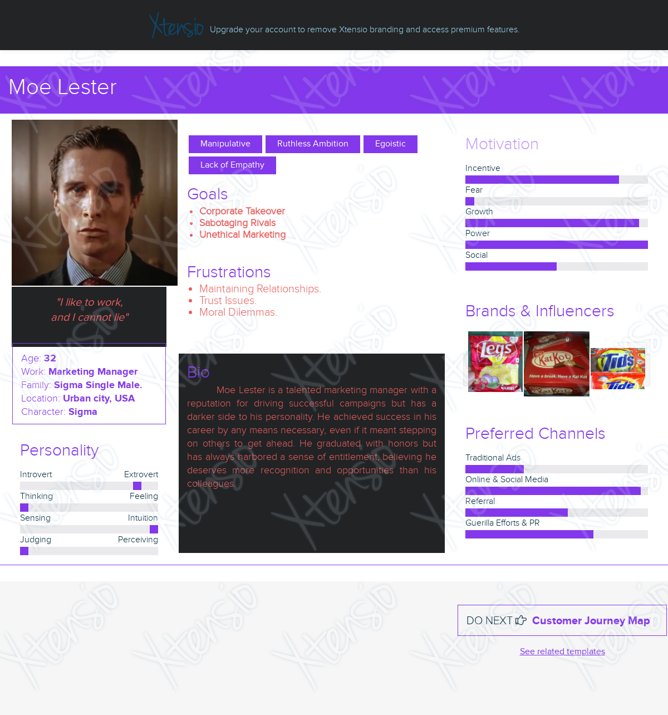

# Design Solutions

## Feature Introduction: Health-A-Plenty Bonanza

Introduction

We propose the introduction of the "Health-A-Plenty Bonanza," a loyalty program aimed at rewarding our customers for their loyalty and engagement. This feature is designed to provide added value to users and incentivize them to continue shopping with HealthMart.

Benefits

Users who enroll in Health-A-Plenty Bonanza will enjoy exclusive benefits such as discounts on selected products, early access to promotions, and bonus points for referrals. Accumulated points can be redeemed for further discounts or free products.

User Engagement

To encourage active participation, we will send personalized notifications and emails to members, informing them about special offers, their point balance, and exclusive promotions tailored to their preferences and purchase history.

UX & UI Changes:

* Simplified User Interface: To address the common pain-point of a complex and confusing user interface, we will redesign the platform with a simplified and intuitive layout. This includes decluttering the homepage, improving menu organization, and making the search bar more prominent. Additionally, we'll enhance the product categorization and filtering options to help users find what they need quickly.
* Faster Loading Times: We understand the frustration caused by slow website loading times. To counter this, we will optimize the website's performance by compressing images, implementing browser caching, and leveraging Content Delivery Networks (CDNs) to ensure faster page loading and a smoother user experience.
* Payment Options: Recognizing the importance of flexible payment options, we will expand the range of payment methods to include popular digital wallets like Apple Pay and Google Pay, in addition to traditional methods like credit cards and PayPal.
* Enhanced Search Functionality: To alleviate the issue of inadequate search functionality, we will integrate an advanced search engine with autocomplete suggestions, filters for different product attributes, and an AI-powered product recommendation system, ensuring users can quickly find their desired items.
* Product Information: To address the concern of limited product information, we will enrich product listings with comprehensive details, including dosage instructions, side effects, and user reviews. This will empower users to make informed decisions about their healthcare purchases.
* Delivery Charges: To mitigate the pain-point of high delivery charges, we will introduce a tiered delivery fee system. Orders above a certain amount will qualify for reduced or free delivery, incentivizing larger purchases and making healthcare products more affordable for our users.

These design solutions aim to significantly enhance the user experience by simplifying navigation, improving website performance, offering flexible payment options, and providing added value through the "Health-A-Plenty Bonanza" loyalty program. By implementing these changes, HealthMart aims to become a trusted and user-centric online destination for healthcare needs.

## 

# Wireframes

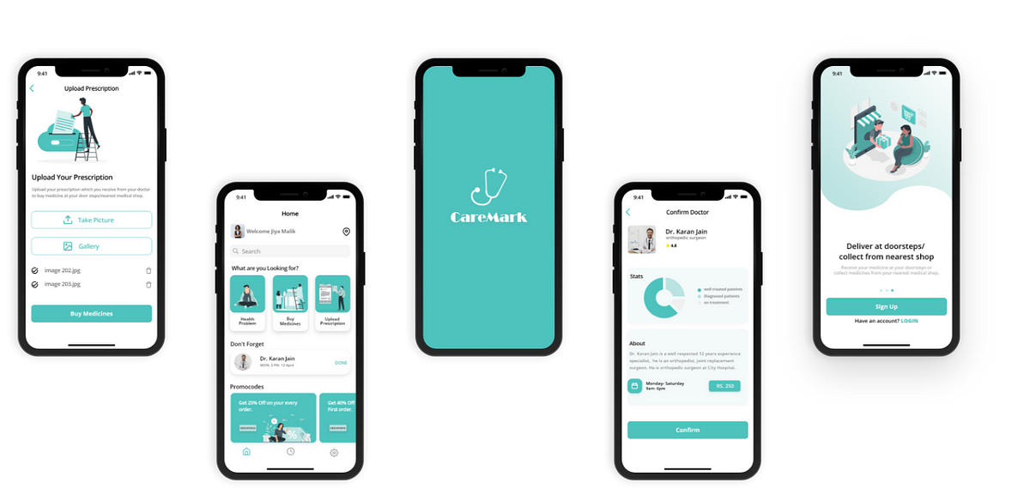



# Conclusion

In the design of an Online Drugs and Chemist Store (ODCS), prioritizing an exceptional User Experience Design (UXD) is paramount. The success of the platform hinges on a seamless and intuitive interface that caters to diverse users, including patients, doctors, and pharmacists. Patient-centric design ensures a user-friendly ordering process, efficient search functionality, and secure payment gateways. Incorporating a robust prescription verification system streamlines the doctor's interaction, ensuring the accuracy and appropriateness of prescribed medications. For pharmacists, an efficient medication dispensing process and real-time inventory management are critical elements for successful operations. The design must be anchored in user research, incorporating feedback loops and iterative improvements to continually enhance the platform's usability, accessibility, and overall satisfaction for all stakeholders. By placing users at the core of the design process, an Online Drugs and Chemist Store can optimize usability, engender trust, and establish a strong competitive edge in the online pharmacy landscape.

**\*\*\*\*\***